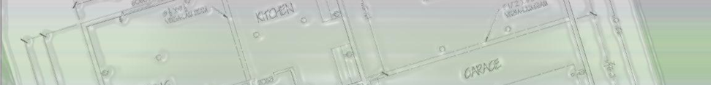
Denise M. Shaw
9441 AL Hwy 40 deniseshaw1967@yahoo.com 256~605~9922
Henagar, AL 35978

PROFESSIONAL SKILLS

- AutoCAD 2012 | - Adobe Photoshop CS 5.1 | - Microsoft Office Suite 2010
- AutoCAD Revit 2012 | - Painting Design | - QuickBooks Pro
- 3D Studio Max | - Residential Painting | - Management
- Mechanical Drafting | - Commercial Painting | - Business Writing & Research
- Computer Drafting | - Faux Finishes | - Estimating
- Java Programming | - Project Planning | - Budgeting
- C++ Programming | - Site Planning | - Forecasting
- HTML | - Lighting Design | - Customer Service
- Web Design | - Critical Thinking | - Communication
- Blueprint Reading | - Image Editing

EDUCATION

Westwood College May, 2013
Associates of Applied Science in Computer-Aided Design / Architectural Drafting
President's List for Academic Excellence, GPA: 3.98
Alpha Beta Kappa National Honor Society

University of Phoenix October, 2011
Associates of Arts in Information Technology / Programming
Dean’s List for Academic Excellence, GPA: 3.85

PROFESSIONAL EXPERIENCE

United States Postal Service (USPS) July 2013 - Present
Postal Support Employee (PSE)

Shaw Painting, Henagar, AL January 2001 - Present
Owner / Operator Residential and Commercial Painting Contractor.

- Directly responsible for meeting with Architects, General Contractors and City Officials to obtain job requirements and blueprints for accurately estimating labor costs, materials and time requirements.
- Provide direct supervision of construction activities at multiple job sites in the Fort Payne area.
- Order and deliver materials, read blueprints and make change orders to satisfy customers.
- Proficient in framing, drywall installation, surface preparation and finishing.
- Expert painting applicator using latex enamels, alkyd enamels and epoxy finishes.
- Excellent creative skills, interior and exterior design and faux finishes.
- Experience in all office managerial activities, hiring and training employees.

New Construction | Existing
Heat Transfer Products Group (2012) | Dr. Halaseh - Medical Office (2012)
Northeast Water Treatment Plant (2011) | Siemens Westinghouse (2012)
Northside Medical (2011) | Guntersville Lake House (2012)
Leesburg Storm Shelter (2011) | Dr. Steven Isbell's Medical Office (2010)
Kevin Callahan Residence (2011) | J. David Dodd, P. A. Residence (2010)
Valley Medical Plaza (2010) | Dr. Halaseh - Residence (2010)
DeKalb County Jail (2010) | Scruggs, Dodd, & Dodd Attorneys, P. A. (2010)
Portfolio
http://shawdenise.wix.com/deniseshaw

